6. High-Fidelity Design

6.1 Introduction

This chapter explores the several steps taken to create the high-fidelity design. The phases involved are: low-fidelity design, initial high-fidelity design and final high-fidelity design. In each phase the steps and difficulties encountered, if any, will be discussed.

6.2 Low-Fidelity Design

The low-fidelity design also known as paper-based design (see Appendix L) was captured on a piece of paper, making it easy to edit the designs.

After a coachee signs in (Screen 1), the coachee is navigated to screen 2, which shows the coaching sessions for a particular coaching programme or pathway. The first coaching session, titled “Title 1” is not booked whilst the second coaching session is booked. Each coaching session has a PDF material, which the coachee can select to download and read. The “Action” drop-down menu displays a list of actions that can be performed on the coaching session e.g. “book a session”, “delete a booked session” etc.

On Screen 2, the drop-down menu, right under the “Programmes” title on navigation bar, displays a side menu containing a list of menus: “My Coaches” and “My Materials”, as shown on Screen 9. Selecting “My Coaches” displays the details of coaches who have been assigned to the coachee (Screen 6).

The low-fidelity design, though an incomplete rough sketch of the proposed mobile app, gave the author a rough idea on how to proceed with the high-fidelity design. Before embarking on the design, the author brushed up his knowledge on Android design guides and consulted current executive coaching applications and social media applications like Facebook.

6.2 Initial High-Fidelity Design

The initial high-fidelity design was achieved using Ionic Creator, an app for rapidly prototyping Ionic apps.

The major change between the low-fidelity design and the initial high-fidelity design is in the Home View (Fig 6.2). Comparing it with Screen 2 of the low-fidelity, the Home View shows a drop-down menu of coaching programmes and coaches. The reason behind this change was: in Screen 2 the “My Coaches” menu was hidden in the side menu, which made it easy to miss. With the design of the Home View, it’s impossible to miss the “My Coaches”.

To view a pathway, a coachee will select a pathway from the drop-down menu and select the “Get Pathway” button. To view details of a coach, a coachee will select a coach and select the “View Details” button.

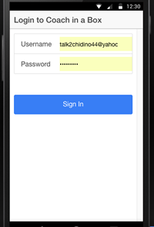 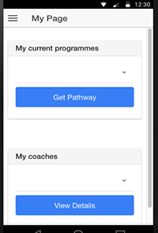

Fig 6.1: Login View Fig 6.2: Home View

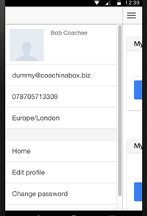 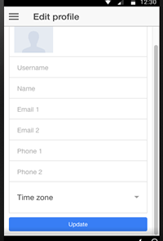

Fig 6.3 Side Menu View Fig 6.4: Edit Profile View

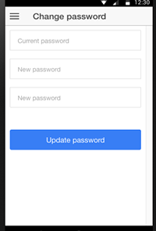

Fig 6.5: Change Password View

I found the Ionic Creator easy to pick up – though I initially had to watch an online video to learn how to use it. Although the Ionic Creator supports rapid prototyping, it has limited UI components.

The author had to work with UI components presented and not with desired UI components. At the time of use, the Ionic Creator had more iOS UI components than Android UI components.

Also the Ionic Creator doesn’t support – at the time of use, tabs and side menu together: it was one or the other. I found the preview feature helpful, as I was able to preview how the UI looked whilst designing it.

Regardless of its limitations, the author found the Ionic Creator to be very useful. The author used two days to create this initial high-fidelity design. The demonstration to the client was received favourably and the feedback was so good, this initial design didn’t warrant any change.

6.3 Final High-Fidelity Design

The next phase was to implement the initial high-fidelity design in Ionic. The author found the Ionic documentations very helpful at this stage. CodePen was another helpful resource – CodePen is a playground for front-end web development. At CodePen, the author found many examples of several Ionic UI interfaces. Finally, online resources like Stack Overflow proved invaluable at this stage.

The Ionic CLI provides the option of previewing the developed app in iOS and Android views by using the command “ionic serve –lab or ionic serve -l”. This enabled the author to preview the app while designing – the default view (ionic serve) is the iOS view. The browser of choice was Chrome and the author found the debugger extremely handy when styling and debugging. Minimal custom styling was used at this stage because of Ionic’s out-of-the-box styling. The Ionic framework comes with many CSS styles that can be applied by using custom classes. The author also started using Git at this stage to manage his source code revision control -- an online repository was created on Github and the local repository was “Git initialised”.

6.3.1 Justification of Final Design and Design Decisions Taken

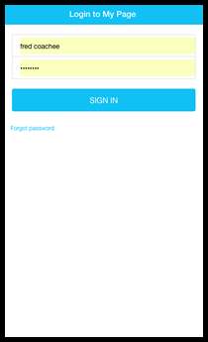

Fig 6.6: Login Screen

The only noticeable difference in the Login Screen (Fig 6.6) from the Login View (Fig 6.1) is the colour used. The author decided to use a similar colour matching that used on Coach in a Box’s website.

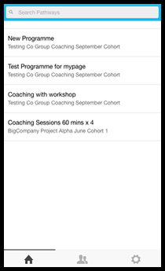

Fig 6.7: Home Screen

The Home Screen spots a search field in the navigation bar that enables coachees to search for a specific pathway. The app uses navigation tabs, which are located at the bottom. Ideally these tabs should be located at the top but the author found it difficult to position both the search field and the navigation tabs at the top. A compromise was made to locate the navigation tabs at the bottom. This compromise will enable reuse of code because iOS demands navigation tabs are located at the bottom whilst Android is not too strict on the location of navigation tabs.

The choice of navigation tabs over side menu was taken so as to openly display the major navigation options available to the coachees, rather than hiding some in a side menu.

Only icons are used to describe the navigation tabs, which is in adherence to the Android design guideline. The first tab represents the Home Page and, as can be seen, displays the list of pathways and their respective cohort names. For example the name of the first pathway is “New Programme” and its cohort is called “Testing Co Group Coaching September Cohort”.

In the initial design of the Home page (Fig 6.2), the coachee performed two actions to view a pathway from the Home page: selecting the pathway from the drop-down menu and selecting “Get Pathway” button. Here the coachee only needs to perform one action to view a pathway: select the pathway, which definitely provides a better user experience.

Still comparing with Fig 6.2, the option to view the details of a coach was moved to the second tab. The reason behind this change is to prevent cluttering of the Home Page. Due to the limited space available in smartphones compared to websites, the author concentrated on displaying detailed information of an object – the pathway, rather than those of several objects – the pathway and coaches.

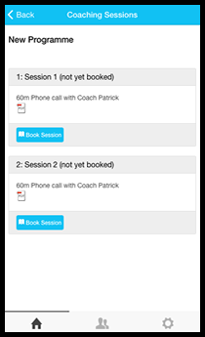

Fig 6.8: Coaching Sessions Screen

A pathway consists of coaching sessions and selecting a pathway displays its coaching sessions. The different types of coaching sessions are Phone Call Coaching, Face-To-Face Coaching, Non-Bookable Coaching, Group Coaching and Self Learning -- more details are presented in the next chapter. Fig 6.8 shows coaching sessions belonging to the “New Programme” pathway; the two coaching sessions have not been booked. Again the colour used to represent a not-yet-booked coaching session matches that used on the website.

Fig 6.9 shows the details of coaches that have been assigned to a coachee. The details of a coach are name, timezone, email address, phone number and biography; additionally a coach’s pic is also shown.

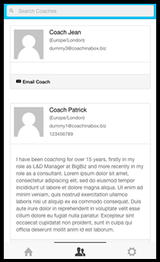 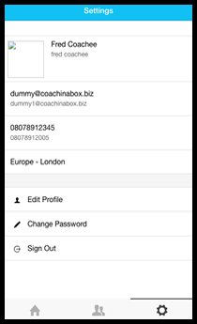

Fig 6.9: Coaches Screen Fig 6.10: Settings Screen

The coaches’ screen above has a search field in the navigation bar that coachees can use to search for a coach. This feature makes it easy to find a coach and improves the user friendliness of the app.

Coachees can email a coach by selecting “Email Coach”. Though Android design guides encourages the use of only icons, the author felt an additional title would clearly state the purpose of the mail icon.

Fig 6.10, the Settings Screen, shows the profile of the coachee and provides options to edit profile, change password and sign out. This design doesn’t hugely depart from that of Fig 6.3; it’s only been given its own tab (Settings Tab).

In Fig 6.11, the ability to edit a coachee’s picture or photo has been provided. Fig 6.12 shows a pop-up when the “change password” option is selected. This pop-up informs the coachee that a confirmation email with instructions on how to change his password will be sent to the coachee’s email address -- this mirrors what’s shown on the website.

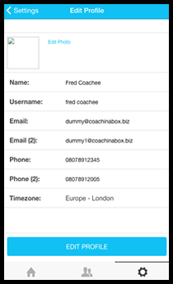 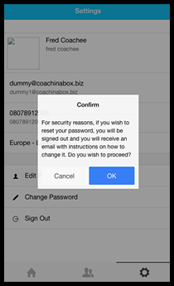

Fig 6.11: Edit Profile Screen Fig 6.12: Change Password Screen

Whilst the feedback from the client was mostly favourably, the client wanted the borders of each coaching sessions in Fig 6.8 to be more visible.

6.4 Conclusion

The Ionic framework encourages rapid mobile app development. For prototyping with Ionic Creator to viewing examples of UI components and user interfaces on CodePen to developing using the Ionic CLI, comprehensive resources are available to assist you in creating a high-fidelity design in a short time.

The UI components of the Ionic framework are clean and their aesthetic quality is high. The framework also provides iOS and Android components, making Ionic apps project a native look and feel. The author stayed away from the native components though because the author plans to reuse most of the UI components for the iOS platform, instead the author chose generic Ionic components.